**PL/SQL**

**M ASWIN KISHORE, S5 CS2 41**

Questions

1. Find the sum of two numbers.

DECLARE

a NUMBER(2) := 10;

b NUMBER(2) := 20;

c NUMBER(2);

BEGIN

c:= a+b;

DBMS_OUTPUT.PUT_LINE('SUM IS: '||c);

END;

**OUPUT**

SUM IS: 30

Statement processed.

1. Program to find the average of a set of 10 numbers.

DECLARE

type GRADES IS VARRAY(10) OF INTEGER;

marks GRADES;

average float := 0;

total integer;

BEGIN

marks := GRADES(61, 57, 78, 87, 92, 10, 29, 70, 30, 80);

total := marks.count;

FOR i in 1 .. total LOOP

average := average + marks(i);

END LOOP;

dbms_output.put_line('Average: ' || average/total);

END;

**OUPUT**

Average: 59.4

1. Program to swap two numbers

DECLARE

a NUMBER(2);

b NUMBER(2);

t NUMBER(2);

BEGIN

a:=10;

b:=20;

DBMS_OUTPUT.PUT_LINE('BEFORE SWAPPING');

DBMS_OUTPUT.PUT_LINE('a: '||a);

DBMS_OUTPUT.PUT_LINE('b: '||b);

t:=a;

a:=b;

b:=t;

DBMS_OUTPUT.PUT_LINE('AFTER SWAPPING');

DBMS_OUTPUT.PUT_LINE('a: '||a);

DBMS_OUTPUT.PUT_LINE('b: '||b);

END;

**OUPUT**

BEFORE SWAPPING

a: 10

b: 20

AFTER SWAPPING

a: 20

b: 10

1. Program to find the average of 5 subjects

DECLARE

type GRADES IS VARRAY(5) OF INTEGER;

marks GRADES;

average FLOAT := 0;

BEGIN

marks:= GRADES(:SUB1,:SUB2,:SUB3,:SUB4,:SUB5);

DBMS_OUTPUT.PUT_LINE('MARKS OF 5 SUBJECTS ENTERED BY USER');

FOR i in 1 .. marks.count LOOP

DBMS_OUTPUT.PUT_LINE('SUB'|| i ||' MARK: '|| marks(i));

average := average + marks(i);

END LOOP;

DBMS_OUTPUT.PUT_LINE('AVERAGE OF 5 SUBJECTS '|| average / marks.count);

END;

**OUTPUT**

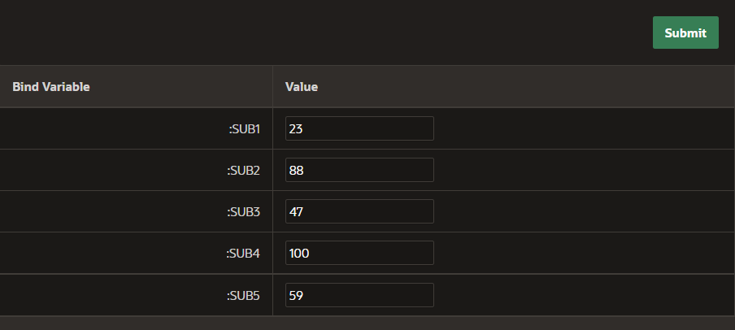

MARKS OF 5 SUBJECTS ENTERED BY USER

SUB1 MARK: 23

SUB2 MARK: 88

SUB3 MARK: 47

SUB4 MARK: 100

SUB5 MARK: 59

AVERAGE OF 5 SUBJECTS 63.4